**Fundamental Techniques of Feature Engineering for Machine Learning**

**All required methods for comprehensive data preprocessing with Pandas examples.**

**Introduction**

What is a feature and why we need the engineering of it? Basically, all machine learning algorithms use some input data to create outputs. This input data comprise features, which are usually in the form of structured columns. Algorithms require features with some specific characteristic to work properly. Here, the need for **feature engineering** arises. I think feature engineering efforts mainly have two goals:

* Preparing the proper input dataset, compatible with the machine learning algorithm requirements.
* Improving the performance of machine learning models.

The features you use influence more than everything else the result. No algorithm alone, to my knowledge, can supplement the information gain given by correct **feature engineering**.

— Luca Massaron

According to a survey in Forbes, data scientists spend **80%** of their time on **data preparation:**

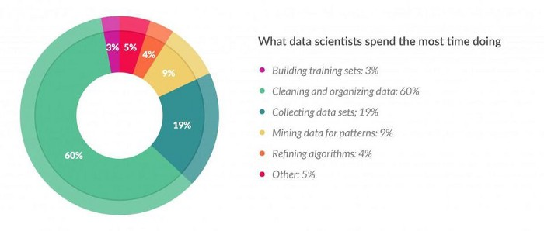

[Source: https://www.forbes.com/sites/gilpress/2016/03/23/data-preparation-most-time-consuming-least-enjoyable-data-science-task-survey-says/](https://www.forbes.com/sites/gilpress/2016/03/23/data-preparation-most-time-consuming-least-enjoyable-data-science-task-survey-says/#1594bda36f63)

This metric is very impressive to show the importance of feature engineering in data science. Thus, I decided to write this article, which summarizes the main techniques of feature engineering with their short descriptions. I also added some basic python scripts for every technique. You need to import **Pandas** and **Numpy** library to run them.

import pandas as pd  
import numpy as np

Some techniques above might work better with some algorithms or datasets, while some of them might be beneficial in all cases. This article does not aim to go so much deep in this aspect. Tough, it is possible to write an article for every method above, I tried to keep the explanations brief and informative. I think the best way to achieve expertise in feature engineering is practicing different techniques on various datasets and observing their effect on model performances.

**List of Techniques**

* [1.Imputation](https://medium.com/p/3a5e293a5114#3abe)
* [2.Handling Outliers](https://medium.com/p/3a5e293a5114#1c08)
* [3.Binning](https://medium.com/p/3a5e293a5114#7559)
* [4.Log Transform](https://medium.com/p/3a5e293a5114#199b)
* [5.One-Hot Encoding](https://medium.com/p/3a5e293a5114#7c18)
* [6.Grouping Operations](https://medium.com/p/3a5e293a5114#ad97)
* [7.Feature Split](https://medium.com/p/3a5e293a5114#3149)
* [8.Scaling](https://medium.com/p/3a5e293a5114#83e6)
* [9.Extracting Date](https://medium.com/p/3a5e293a5114#8068)

**1.Imputation**

Missing values are one of the most common problems you can encounter when you try to prepare your data for machine learning. The reason for the missing values might be human errors, interruptions in the data flow, privacy concerns, and so on. Whatever is the reason, missing values affect the performance of the machine learning models.

Some machine learning platforms automatically drop the rows which include missing values in the model training phase and it decreases the model performance because of the reduced training size. On the other hand, most of the algorithms do not accept datasets with missing values and gives an error.

The most simple solution to the missing values is to drop the rows or the entire column. There is not an optimum threshold for dropping but you can use **70%** as an example value and try to drop the rows and columns which have missing values with higher than this threshold.

threshold = 0.7**#Dropping columns with missing value rate higher than threshold**  
data = data[data.columns[data.isnull().mean() < threshold]]  
  
**#Dropping rows with missing value rate higher than threshold**  
data = data.loc[data.isnull().mean(axis=1) < threshold]

**Numerical Imputation**

Imputation is a more preferable option rather than dropping because it preserves the data size. However, there is an important selection of what you impute to the missing values. I suggest beginning with considering a possible default value of missing values in the column. For example, if you have a column that only has **1** and **NA**, then it is likely that the **NA** rows correspond to **0**. For another example, if you have a column that shows the **“customer visit count in last month”**, the missing values might be replaced with **0** as long as you think it is a sensible solution.

Another reason for the missing values is joining tables with different sizes and in this case, imputing **0** might be reasonable as well.

Except for the case of having a default value for missing values, I think the best imputation way is to use the **medians** of the columns. As the averages of the columns are sensitive to the outlier values, while medians are more solid in this respect.

**#Filling all missing values with 0**  
data = data.fillna(0)**#Filling missing values with medians of the columns**  
data = data.fillna(data.median())

**Categorical Imputation**

Replacing the missing values with the **maximum occurred value** in a column is a good option for handling categorical columns. But if you think the values in the column are distributed uniformly and there is not a dominant value, imputing a category like “**Other**” might be more sensible, because in such a case, your imputation is likely to converge a random selection.

**#Max fill function for categorical columns**  
data['column_name'].fillna(data['column_name'].value_counts()  
.idxmax(), inplace=True)

**2.Handling Outliers**

Before mentioning how outliers can be handled, I want to state that the best way to detect the outliers is to demonstrate the data visually. All other statistical methodologies are open to making mistakes, whereas visualizing the outliers gives a chance to take a decision with high precision. Anyway, I am planning to focus visualization deeply in another article and let’s continue with statistical methodologies.

Statistical methodologies are less precise as I mentioned, but on the other hand, they have a superiority, they are fast. Here I will list two different ways of handling outliers. These will detect them using **standard deviation**, and **percentiles**.

**Outlier Detection with Standard Deviation**

If a value has a distance to the average higher than ***x * standard deviation*,** it can be assumed as an outlier. Then what **x** should be?

There is no trivial solution for x, but usually, a value between 2 and 4 seems practical.

**#Dropping the outlier rows with standard deviation**  
factor = 3  
upper_lim = data['column'].mean () + data['column'].std () * factor  
lower_lim = data['column'].mean () - data['column'].std () * factor  
  
data = data[(data['column'] < upper_lim) & (data['column'] > lower_lim)]

In addition, **z-score** can be used instead of the formula above. **Z-score** (or standard score) standardizes the distance between a value and the mean using the standard deviation.

**Outlier Detection with Percentiles**

Another mathematical method to detect outliers is to use percentiles. You can assume a certain percent of the value from the top or the bottom as an outlier. The key point is here to set the percentage value once again, and this depends on the distribution of your data as mentioned earlier.

Additionally, a common mistake is using the percentiles according to the range of the data. In other words, if your data ranges from **0** to **100**, your top **5%** is not the values between **96** and **100**. Top **5%** means here the values that are out of the **95th** percentile of data.

**#Dropping the outlier rows with Percentiles**  
upper_lim = data['column'].quantile(.95)  
lower_lim = data['column'].quantile(.05)  
  
data = data[(data['column'] < upper_lim) & (data['column'] > lower_lim)]

**An Outlier Dilemma: Drop or Cap**

Another option for handling outliers is to **cap** them instead of dropping. So you can keep your data size and at the end of the day, it might be better for the final model performance.

On the other hand, capping can affect the distribution of the data, thus it better not to exaggerate it.

**#Capping the outlier rows with Percentiles**  
upper_lim = data['column'].quantile(.95)  
lower_lim = data['column'].quantile(.05)data.loc[(df[column] > upper_lim),column] = upper_lim  
data.loc[(df[column] < lower_lim),column] = lower_lim

**3.Binning**

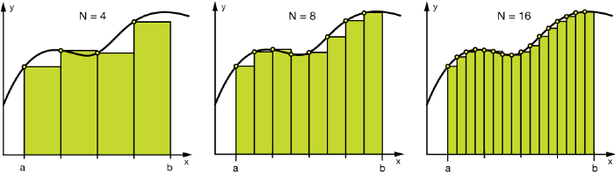

Binning illustration of numerical data

Binning can be applied on both categorical and numerical data:

**#Numerical Binning ExampleValue Bin**   
0-30 -> Low   
31-70 -> Mid   
71-100 -> High**#Categorical Binning ExampleValue Bin**   
Spain -> Europe   
Italy -> Europe   
Chile -> South America  
Brazil -> South America

The main motivation of binning is to make the model more **robust** and prevent **overfitting**, however, it has a cost to the performance. Every time you bin something, you sacrifice information and make your data more regularized. (Please see [regularization in machine learning](https://towardsdatascience.com/regularization-in-machine-learning-76441ddcf99a))

The trade-off between **performance** and **overfitting** is the key point of the binning process. In my opinion, for numerical columns, except for some obvious overfitting cases, binning might be redundant for some kind of algorithms, due to its effect on model performance.

However, for categorical columns, the labels with low frequencies probably affect the robustness of statistical models negatively. Thus, assigning a general category to these less frequent values helps to keep the robustness of the model. For example, if your data size is **100,000** rows, it might be a good option to unite the labels with a count less than **100** to a new category like **“Other”**.

**#Numerical Binning Example**data['bin'] = pd.cut(data['value'], bins=[0,30,70,100], labels=["Low", "Mid", "High"]) **value bin**  
0 2 Low  
1 45 Mid  
2 7 Low  
3 85 High  
4 28 Low**#Categorical Binning Example** **Country**  
0 Spain  
1 Chile  
2 Australia  
3 Italy  
4 Brazilconditions = [  
 data['Country'].str.contains('Spain'),  
 data['Country'].str.contains('Italy'),  
 data['Country'].str.contains('Chile'),  
 data['Country'].str.contains('Brazil')]  
  
choices = ['Europe', 'Europe', 'South America', 'South America']  
  
data['Continent'] = np.select(conditions, choices, default='Other') **Country Continent**  
0 Spain Europe  
1 Chile South America  
2 Australia Other  
3 Italy Europe  
4 Brazil South America

**4.Log Transform**

Logarithm transformation (or log transform) is one of the most commonly used mathematical transformations in feature engineering. What are the benefits of log transform:

* It helps to handle skewed data and after transformation, the distribution becomes more approximate to normal.
* In most of the cases the magnitude order of the data changes within the range of the data. For instance, the difference between ages **15** and **20** is not equal to the ages **65** and **70**. In terms of years, yes, they are identical, but for all other aspects, **5** years of difference in young ages mean a higher magnitude difference. This type of data comes from a multiplicative process and log transform normalizes the magnitude differences like that.
* It also decreases the effect of the outliers, due to the normalization of magnitude differences and the model become more robust.

**A critical note:** The data you apply log transform must have only positive values, otherwise you receive an error. Also, you can add **1** to your data before transform it. Thus, you ensure the output of the transformation to be positive.

**Log(x+1)**

**#Log Transform Example**  
data = pd.DataFrame({'value':[2,45, -23, 85, 28, 2, 35, -12]})data['log+1'] = (data['value']+1).transform(np.log)**#Negative Values Handling  
#Note that the values are different**data['log'] = (data['value']-data['value'].min()+1) .transform(np.log) **value log(x+1) log(x-min(x)+1)**  
0 2 1.09861 3.25810  
1 45 3.82864 4.23411  
2 -23 nan 0.00000  
3 85 4.45435 4.69135  
4 28 3.36730 3.95124  
5 2 1.09861 3.25810  
6 35 3.58352 4.07754  
7 -12 nan 2.48491

**5.One-hot encoding**

**One-hot encoding** is one of the most common encoding methods in machine learning. This method spreads the values in a column to multiple flag columns and assigns **0** or **1** to them. These binary values express the relationship between grouped and encoded column.

This method changes your categorical data, which is challenging to understand for algorithms, to a numerical format and enables you to group your categorical data without losing any information. (For details please see the last part of **Categorical Column Grouping**)

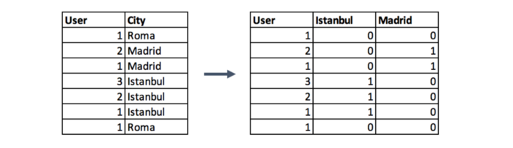

One hot encoding example on City column

**Why One-Hot?:** If you have **N** distinct values in the column, it is enough to map them to **N-1** binary columns, because the missing value can be deducted from other columns. If all the columns in our hand are equal to **0**, the missing value must be equal to **1**. This is the reason why it is called as **one-hot encoding**. However, I will give an example using the **get_dummies** function of Pandas. This function maps all values in a column to multiple columns.

encoded_columns = pd.get_dummies(data['column'])  
data = data.join(encoded_columns).drop('column', axis=1)

**6.Grouping Operations**

In most machine learning algorithms, every instance is represented by a row in the training dataset, where every column show a different feature of the instance. This kind of data called **“Tidy”**.

Tidy datasets are easy to manipulate, model and visualise, and have a specific structure: each variable is a column, each observation is a row, and each type of observational unit is a table.

— Hadley Wickham

Datasets such as transactions rarely fit the definition of tidy data above, because of the multiple rows of an instance. In such a case, we group the data by the instances and then every instance is represented by only one row.

The key point of group by operations is to decide the aggregation functions of the features. For numerical features, average and sum functions are usually convenient options, whereas for categorical features it more complicated.

**Categorical Column Grouping**

I suggest three different ways for aggregating categorical columns:

* The first option is to select the label with the **highest frequency**. In other words, this is the **max** operation for categorical columns, but ordinary max functions generally do not return this value, you need to use a lambda function for this purpose.

data.groupby('id').agg(lambda x: x.value_counts().index[0])

* Second option is to make a **pivot table**. This approach resembles the encoding method in the preceding step with a difference. Instead of binary notation, it can be defined as aggregated functions for the values between grouped and encoded columns. This would be a good option if you aim to go beyond binary flag columns and merge multiple features into aggregated features, which are more informative.

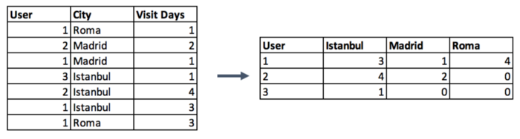

Pivot table example: Sum of Visit Days grouped by Users

**#Pivot table Pandas Example**data.pivot_table(index='column_to_group', columns='column_to_encode', values='aggregation_column', aggfunc=np.sum, fill_value = 0)

* Last categorical grouping option is to apply a **group by** function after applying **one-hot encoding**. This method preserves all the data -in the first option you lose some-, and in addition, you transform the encoded column from categorical to numerical in the meantime. You can check the next section for the explanation of **numerical column grouping**.

**Numerical Column Grouping**

Numerical columns are grouped using **sum** and **mean** functions in most of the cases. Both can be preferable according to the meaning of the feature. For example, if you want to obtain **ratio** columns, you can use the average of binary columns. In the same example, sum function can be used to obtain the total count either.

#sum_cols: List of columns to sum  
#mean_cols: List of columns to averagegrouped = data.groupby('column_to_group')  
  
sums = grouped[sum_cols].sum().add_suffix('_sum')  
avgs = grouped[mean_cols].mean().add_suffix('_avg')  
  
new_df = pd.concat([sums, avgs], axis=1)

**7.Feature Split**



Photo by [Jaxon Lott](https://unsplash.com/@jaxonlott?utm_source=medium&utm_medium=referral) on [Unsplash](https://unsplash.com?utm_source=medium&utm_medium=referral)

Splitting features is a good way to make them useful in terms of machine learning. Most of the time the dataset contains string columns that violates [tidy data](http://vita.had.co.nz/papers/tidy-data.html) principles. By extracting the utilizable parts of a column into new features:

* We enable machine learning algorithms to comprehend them.
* Make possible to bin and group them.
* Improve model performance by uncovering potential information.

**Split** function is a good option, however, there is no one way of splitting features. It depends on the characteristics of the column, how to split it. Let’s introduce it with two examples. First, a simple split function for an ordinary name column:

**data.name**  
0 Luther N. Gonzalez  
1 Charles M. Young  
2 Terry Lawson  
3 Kristen White  
4 Thomas Logsdon#Extracting first names **data.name.str.split(" ").map(lambda x: x[0])**0 Luther  
1 Charles  
2 Terry  
3 Kristen  
4 Thomas#Extracting last names **data.name.str.split(" ").map(lambda x: x[-1])**0 Gonzalez  
1 Young  
2 Lawson  
3 White  
4 Logsdon

The example above handles the names longer than two words by taking only the first and last elements and it makes the function robust for corner cases, which should be regarded when manipulating strings like that.

Another case for split function is to extract a string part between two chars. The following example shows an implementation of this case by using two split functions in a row.

#String extraction example **data.title.head()**  
0 Toy Story (1995)  
1 Jumanji (1995)  
2 Grumpier Old Men (1995)  
3 Waiting to Exhale (1995)  
4 Father of the Bride Part II (1995)**data.title.str.split("(", n=1, expand=True)[1].str.split(")", n=1, expand=True)[0]**0 1995  
1 1995  
2 1995  
3 1995  
4 1995

**8.Scaling**

In most cases, the numerical features of the dataset do not have a certain **range** and they differ from each other. In real life, it is nonsense to expect **age** and **income** columns to have the same range. But from the machine learning point of view, how these two columns can be compared?

Scaling solves this problem. The continuous features become identical in terms of the range, after a scaling process. This process is not mandatory for many algorithms, but it might be still nice to apply. However, the algorithms based on **distance** calculations such as **k-NN** or **k-Means** need to have scaled continuous features as model input.

Basically, there are two common ways of scaling:

**Normalization**

https://miro.medium.com/max/168/1*D3ORMiW9A7GoTezFYbL8LA.png

Normalization (or **min-max normalization**) scale all values in a fixed range between **0** and **1**. This transformation does not change the distribution of the feature and due to the decreased standard deviations, the effects of the **outliers** increases. Therefore, before normalization, it is recommended to handle the outliers.

data = pd.DataFrame({'value':[2,45, -23, 85, 28, 2, 35, -12]})  
  
data['normalized'] = (data['value'] - data['value'].min()) / (data['value'].max() - data['value'].min()) **value normalized**  
0 2 0.23  
1 45 0.63  
2 -23 0.00  
3 85 1.00  
4 28 0.47  
5 2 0.23  
6 35 0.54  
7 -12 0.10

**Standardization**

Standardization (or **z-score normalization**) scales the values while taking into account standard deviation. If the standard deviation of features is different, their range also would differ from each other. This reduces the effect of the outliers in the features.

In the following formula of standardization, the **mean** is shown as ***μ*** and the **standard** **deviation** is shown as ***σ***.

https://miro.medium.com/max/82/1*BcNLM9loyAR3YQLt2hDqqg.png

data = pd.DataFrame({'value':[2,45, -23, 85, 28, 2, 35, -12]})  
  
data['standardized'] = (data['value'] - data['value'].mean()) / data['value'].std() **value standardized**  
0 2 -0.52  
1 45 0.70  
2 -23 -1.23  
3 85 1.84  
4 28 0.22  
5 2 -0.52  
6 35 0.42  
7 -12 -0.92

**9.Extracting Date**

Though date columns usually provide valuable information about the model target, they are neglected as an input or used nonsensically for the machine learning algorithms. It might be the reason for this, that dates can be present in numerous formats, which make it hard to understand by algorithms, even they are simplified to a format like **"01–01–2017"**.

Building an ordinal relationship between the values is very challenging for a machine learning algorithm if you leave the date columns without manipulation. Here, I suggest three types of preprocessing for dates:

* Extracting the parts of the date into different columns: Year, month, day, etc.
* Extracting the time period between the current date and columns in terms of years, months, days, etc.
* Extracting some specific features from the date: Name of the weekday, Weekend or not, holiday or not, etc.

If you transform the date column into the extracted columns like above, the information of them become disclosed and machine learning algorithms can easily understand them.

from datetime import date  
  
data = pd.DataFrame({'date':  
['01-01-2017',  
'04-12-2008',  
'23-06-1988',  
'25-08-1999',  
'20-02-1993',  
]})  
  
**#Transform string to date**  
data['date'] = pd.to_datetime(data.date, format="%d-%m-%Y")  
  
**#Extracting Year**  
data['year'] = data['date'].dt.year  
  
**#Extracting Month**  
data['month'] = data['date'].dt.month  
  
**#Extracting passed years since the date**  
data['passed_years'] = date.today().year - data['date'].dt.year  
  
**#Extracting passed months since the date**  
data['passed_months'] = (date.today().year - data['date'].dt.year) * 12 + date.today().month - data['date'].dt.month  
  
**#Extracting the weekday name of the date**  
data['day_name'] = data['date'].dt.day_name() **date year month passed_years passed_months day_name**  
0 2017-01-01 2017 1 2 26 Sunday  
1 2008-12-04 2008 12 11 123 Thursday  
2 1988-06-23 1988 6 31 369 Thursday  
3 1999-08-25 1999 8 20 235 Wednesday  
4 1993-02-20 1993 2 26 313 Saturday

**Conclusion**

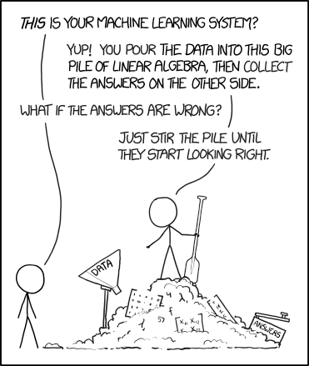

<https://xkcd.com/1838/>

I tried to explain fundamental methods that can be beneficial in the feature engineering process. After this article, proceeding with other topics of data preparation such as **feature selection, train/test splitting,** and **sampling** might be a good option.

You can check my [other article about Oversampling](https://towardsdatascience.com/how-to-calibrate-undersampled-model-scores-8f3319c1ea5b).

Lastly, I want to conclude the article with a reminder. These techniques are not magical tools. If your data tiny, dirty and useless, feature engineering may remain incapable. Do not forget *“****garbage in, garbage out!”***

**References**

* [**Stack Overflow**](https://stackoverflow.com/) questions are very beneficial for every kind of feature engineering script.
* I highly recommend [**Kaggle**](https://www.kaggle.com) competitions and their discussion boards.
* [**Ways to Detect and Remove the Outliers**](https://towardsdatascience.com/ways-to-detect-and-remove-the-outliers-404d16608dba)
* [**Understanding Feature Engineering (Part 1) — Continuous Numeric Data**](https://towardsdatascience.com/understanding-feature-engineering-part-1-continuous-numeric-data-da4e47099a7b)
* [**Understanding Feature Engineering (Part 2) — Categorical Data**](https://towardsdatascience.com/understanding-feature-engineering-part-2-categorical-data-f54324193e63)
* [**Log Transformations for Skewed and Wide Distributions**](https://www.r-statistics.com/2013/05/log-transformations-for-skewed-and-wide-distributions-from-practical-data-science-with-r/)
* [**Tidy data**](http://vita.had.co.nz/papers/tidy-data.html)
* [**About Feature Scaling and Normalization**](https://sebastianraschka.com/Articles/2014_about_feature_scaling.html)